The first ship has set sails!

The highly motivated crew of the Flex4RES flagship set sails on the 12-13 of November 2015, with an official kick-off meeting at DTU in Denmark. The Nordic-Baltic crew is 24 members strong, and has set an clear and ambitious course for the next 4 years ahead.
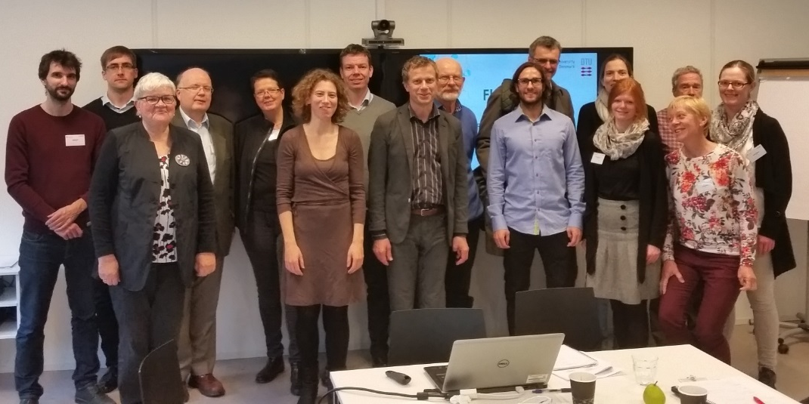
Picture 1: The Nordic-Baltic crew, and two passengers from Nordic Energy Research on the right, on the maiden voyage of Flex4RES.
Flex4Res is one of the three new Flagship projects in Nordic Energy Research’s small, but strong fleet/flotilla/squadron. The Flex4RES captain and project manager, Klaus Skytte, leads the crew from Denmark, Norway, Sweden, Finland, Estonia, and Latvia.
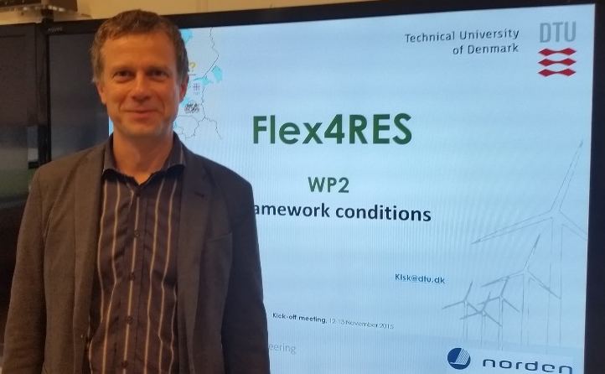
Picture 2: Klaus Skytte, the captain (klsk@dtu.dk).
Already from the start, they displayed great team spirit and a clear drive to make a difference with the Flex4RES project. They aim to find the path to a common/coherent/unified Nordic-Baltic energy system in the year 2050, through the maze of regulatory and technical differences in the participating countries. On their journey, they want to integrate and consolidate the different, renewable energy markets/sources to make a solid base to anchor resilient, sustainable and cost-efficient Nordic energy systems. There is a clear ambition/expressed goal to reach policy makers and set the course in direction of coherent policy and regulatory frameworks. This can facilitate the integration of variable renewable energy (VRE) sources into the current Nordic Energy market. We (in Nordic Energy Research) wish them Bon Voyage!
Project partners:
