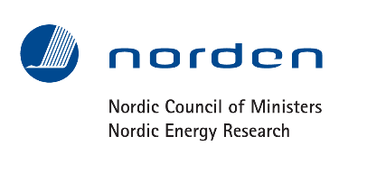

FOR IMMEDIATE RELEASE:
Stockholm, Sweden – May 23rd, 2016

Nordic researchers and IEA: Transport, industry and flexibility are the greatest challenges in achieving a carbon-neutral Nordic energy system

Today Nordic Energy Research and the International Energy Agency (IEA) launch Nordic Energy Technology Perspectives 2016 in Stockholm, a Nordic edition of the IEA's global publication Energy Technology Perspectives. The report reveals that through regional cooperation, the Nordic countries can achieve a near carbon-neutral energy system by 2050, while contributing to European decarbonisation through the export of clean electricity. However, it will require a dramatic restructuring of the transport sector, accelerated innovation to reduce industrial emissions, and greater flexibility in the energy system to handle higher shares of variable renewables.

Cooperation between the Nordic countries on electricity grids and markets has helped the region achieve an 87% decarbonised power supply. CO₂ emissions per unit of electricity generated are currently at the level the world reaches in 2045 in the IEA’s global 2-degree scenario. While decarbonising electricity is still a central challenge for much of the world, the Nordic case offers insight into how a clean electricity system can facilitate decarbonisation of other sectors. These final steps toward carbon-neutrality are critical to achieving the ambitions of the Paris Agreement.

Research teams from all five Nordic countries have worked closely with the IEA to assess the technical and economic potential to reduce Nordic energy-related CO₂ by 85% in 2050, compared to 1990 levels. This is broadly consistent with the climate targets of the Nordic governments. Already in 1990, some Nordic countries emitted as little as half the CO₂ per unit of energy demand compared to the OECD average. An 85% reduction from this low starting point is therefore highly ambitious. The results of the analysis are positive – the Nordic Carbon-Neutral Scenario is technically feasible with manageable investment needs.

The greatest emissions reduction must come from the transport sector. Transport currently accounts for 40% of Nordic CO₂ emissions, and transport activity is set to grow rapidly towards 2050. Progress is already evident – a fifth of all car sales in Norway were electric in 2015. However, electrifying the vast majority of Nordic passenger vehicles towards 2050 will require greater utilisation of the wide range of policy tools available. In addition to electrification, shifting from trucks to trains and from private cars to public transport will be critical. Long-distance transport – where electrification is difficult – will require a dramatic increase in the use of biofuels.

Many key low-carbon solutions are best suited to urban settings, which have higher population densities and shorter distances. Examples include district heating, public transport and electric vehicles. Many Nordic cities lead their national governments, both in terms of climate target ambition and in emissions reduction. Nordic urban areas are set to grow at double the rate of previous decades, creating an opportunity to accelerate energy system transition through urban leadership.

Energy-intensive industries contribute a significant share of both Nordic GDP and CO₂ emissions. Industries common in the Nordic countries – such as iron and steel – have a relatively high share of process-related emissions, which cannot be mitigated through energy efficiency or renewable energy. While a share of these emissions can be reduced through process optimisation, the remainder will require that Carbon Capture and Storage becomes commercially attractive in the next 15 to 20 years, capturing a third of industrial CO₂ by 2050.

The Nordic countries have an economic opportunity to capitalise on their significant potential for additional wind power, and on the region’s large share of existing dispatchable hydropower. Further expansion of transmission lines to the continent will enable the Nordic region to help meet Europe's demand for clean electricity, while simultaneously balancing the variable supply from European wind and solar. Greater integration with the European electricity grid can lead to higher and more variable electricity prices in the Nordic region. This can benefit Nordic power generators and grid operators, while impacting energy-intensive industries. Policies will be instrumental in balancing further European integration with industrial competitiveness.

With wind growing from 7% of Nordic generation in 2013 to 30% in 2050 – and to 70% in Denmark – the need for flexibility in the energy system becomes more acute. Without which, variable wind power will lead to volatile electricity prices that impact consumers and discourage further investment in generation capacity. Dispatchable hydropower, combined with a substantial buildout of domestic and cross-border transmission grids, provides much of the flexibility needed. However, significant additional flexibility is required from the district heating system, through flexible co-generation plants, utility-scale heat pumps and electric boilers, as well as heat storage. Furthermore, flexibility from demand response in industry, buildings and electric vehicles has the potential to facilitate even higher Nordic wind build-out and net electricity export to Europe than seen in the Nordic Carbon-Neutral Scenario.
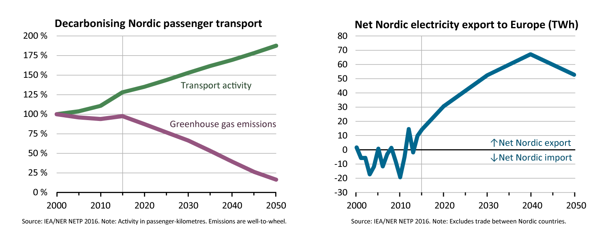The left figure illustrates the significant challenge in transport: Despite steady growth in activity, emissions need to drop by 80% in the Nordic Carbon-Neutral Scenario.
The right figure shows net export of electricity from the Nordic countries, responding to higher electricity prices in Europe. The decrease from 2040 is due to the phase-out of Swedish nuclear capacity.

The report will be launched in all Nordic capitals during May and June of 2016. For more information, or to order a free hardcopy of the report, visit: www.NordicETP.org

Contact:
Markus Wråke, Project manager, markus.wrake@ivl.se, +46 73 078 97 42
Benjamin Donald Smith, Project coordinator, benjamin.smith@nordicenergy.org, +47 90 40 62 03

